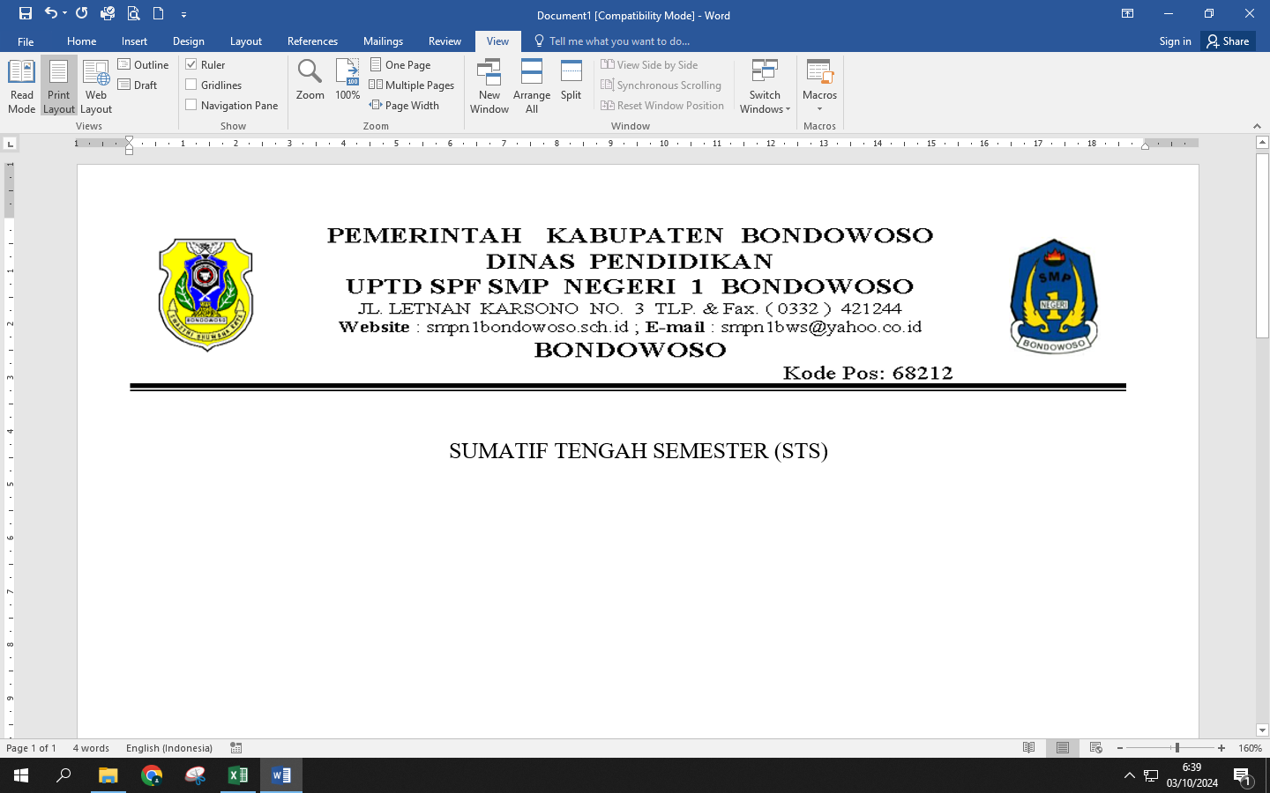

**ASESMEN SUMATIF AKHIR GENAP**

**TAHUN PELAJARAN 2024/2025**

**NAMA : ………………………………………… Mapel : Bahasa Inggris**

**KELAS : 9 NO.ABSEN : …….. Tanggal : ………………………………….**

**Answer the questions!**

1. Upcycling is**…**
2. What is the difference of upcycling and recycling?
3. What is sale mean?
4. What is the difference of sale and on sale?
5. What do you know about donation, tell a brief?
6. Do you need an advertisement to sell your product, why?
7. Mention about digital life!
8. Explain about upload and download!
9. What do you know about phishing?
10. How can I identify fake news on my social feed?

**Answer :**